‘Shocked’ by Attack on Mosque, Nigeria Tightens Security in Northeast
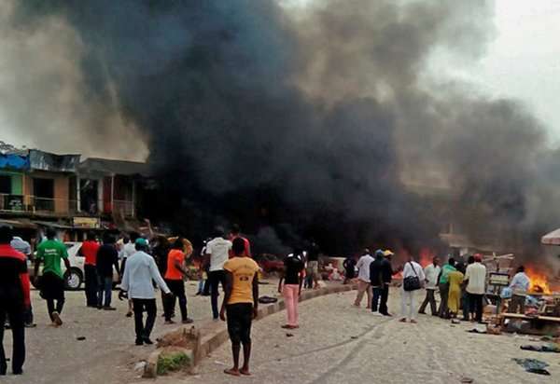
Suicide bombers attacked a market and a mosque on Tuesday in Mubi, Nigeria, killing at least 27 people.CreditEPA, via Shutterstock
By Emmanuel Akinwotu and Aurelien Breeden
May 2, 2018
ABUJA, Nigeria — Twin suicide bombings at a mosque and at a market have left at least 27 people dead and scores wounded in northeastern Nigeria, leading the authorities on Wednesday to tighten security in the region, which has been targeted repeatedly in recent years by Boko Haram, the rebel Islamist insurgency.
The bombings took place around 1 p.m. on Tuesday during afternoon prayers in Mubi, a town roughly 120 miles north of Yola, the capital of Adamawa State. The suicide bombers, two young men, detonated a first bomb after prayers began and a second one outside as people fled, according to the police.
Usman Abubakar, a local police spokesman, said 27 people were killed and 58 were wounded by the suicide bombers, which he said were believed to have been Boko Haram militants. “For a long time we haven’t experienced anything on this scale,” Mr. Abubakar said.
Some news reports, citing local residents and witnesses at burial ceremonies, said the death toll could be much higher, with over 60 victims. The news agency Agence France-Presse quoted gravediggers as saying that they had buried 86 bodies after the bombings, but it was not immediately possible to verify that figure.
Mr. Abubakar said that many victims were “seriously injured” but that the police had “no information regarding an increase in deaths.” Conflicting accounts of the number of deaths in attacks in the region are not uncommon, and the authorities have been keen to play down the severity of such attacks ahead of elections next year.
Dr. Edgar Sakawa, the director of the hospital in Mubi, said that most of the wounded were adults and that 11 victims had been transported to a larger, federal hospital in Yola because of the severity of their wounds. “It’s been very difficult, a very sad attack, but we are doing all we can do,” he said, adding that his hospital had counted 27 deaths but that some victims were taken directly to a cemetery for burial and might not have been counted in the official toll.
Yemi Osinbajo, Nigeria’s vice president, said in a statement from his office on Wednesday that the government was “shocked and outraged” by the bombings. “This desecration of a place of worship by criminals is tragic and condemnable,” Mr. Osinbajo said in the statement, adding that the authorities were working “to beef up security” in and around Mubi, “especially markets and places of worship.”
Mubi, a city of about 175,000 people near the border with Cameroon, is among a number of towns and villages where Boko Haram fighters once held control before being ousted by the military.
Boko Haram, a radical Islamist group that has waged war for the past nine years in Nigeria and in neighboring countries, has sent suicide bombers in a wave of recent attacks on mosques, checkpoints, markets and even camps for some of the nearly two million people uprooted from their homes because of the conflict.
The suicide bombers, many of whom are women and children, have been sent to attack Maiduguri, the capital of Borno State and the city where the Boko Haram movement was founded, as well as smaller towns and villages across the countryside and settlements in neighboring countries.
In November, at least 50 people were killed in Mubi after a suicide bombing that also struck a mosque.
“Civilians are consistently bearing the brunt of this conflict, and I urge the government of Nigeria to step up the protection of innocent people,” said Edward Kallon, the United Nations humanitarian coordinator in Nigeria.
“Close to 200 women, children and men have now been killed in brutal and indiscriminate attacks by nonstate armed groups in the northeast since the beginning of the year, including in the town of Bama last month in Borno State,” Mr. Kallon said in a statement.
In April, at least four people were killed and seven were wounded in a suicide bombing in Bama, a town that had been overrun by the insurgency. A month earlier, the state government had declared that it was safe for residents to return.
Since December 2015, the Nigerian government has repeatedly claimed that Boko Haram has been defeated, after what was thought to be the group’s main base, in the vast Sambisa Forest in Borno State, was taken by the military. But attacks have continued. Boko Haram militants have also made international headlines for their kidnapping of schoolgirls, from Chibok, a town in Borno State, in 2014; and from Dapchi, a town in the neighboring Yobe State, this year.
The bombings in Mubi came just days after President Muhammadu Buhari of Nigeria met in Washington with President Trump, becoming the first African leader to visit the White House since Mr. Trump took office. During their meeting, Mr. Trump pledged American support in the fight against Boko Haram and said he was pleased about the sale of a dozen A-29 Super Tucano warplanes to Nigeria.
The $600 million sale, long sought by the Nigerians, had been held up by the Obama administration amid concerns about human rights abuses by Nigeria’s military. There have also been concerns about whether light attack aircraft would be as helpful as ground troops in the fight against Boko Haram, which no longer fields large groups of fighters in the open, using lone suicide bombers to attack civilians instead.
Mr. Buhari was still in the United States at the time of the bombings, but he has since left Washington for Abuja, the Nigerian capital. Mr. Buhari said last month that he intended to seek re-election in Nigeria’s 2019 presidential race, despite calls for him to step down and criticism of his government’s inability to quell the Boko Haram insurgency.
Emmanuel Akinwotu reported from Abuja, Nigeria, and Aurelien Breeden from Dakar, Senegal.

