MIDTERM Review 2017
Chapter 17 - Thermochemistry
17.1 – The flow of Energy – Heat and Flow
- Chemical potential energy
  - System
  - Surroundings
  - Law of conservation of energy
  - Endothermic processes
  - Exothermic processes
  - Heat capacity
  - Specific heat –
    - units used
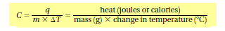
17.2 Measuring and expressing Enthalpy Change
- Calorimetry
- Calorimeter
- Enthalpy (H)
- Q = ΔH
- 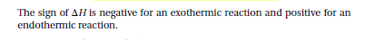
- Thermochemical Equations
or
- Heat of reaction ΔH
- Heat of combustion ΔH
- Enthalpy diagrams
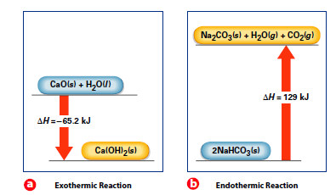
17.3 Heat in Changes of State
- Heats of fusion and solidification
  - Molar heat of fusion
  - Molar heat of solidification
  - 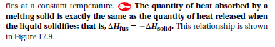
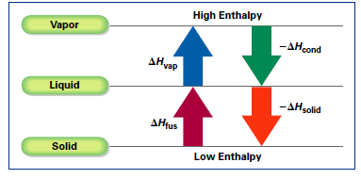
- Heats of vaporization and condensation
  - Molar heat of vaporization
  - Molar heat of condensation
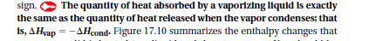
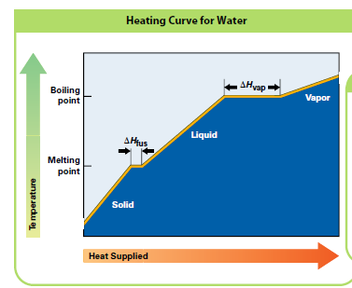
- Heat of Solution
  - During the formation of a solution, heat is either released or absorbed
  - Molar heat of solution ΔH_{soln}
17.4 Calculating Heats of Reaction
- Hess’s Law of heat summation
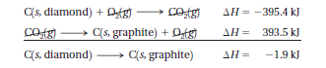
- Standard Heats of Formation
- 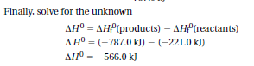

Chapter 18 – Reaction Rates and Equilibrium
18.1 – Rates of Reaction
- Collision theory
- Activation energy
- Activated complex
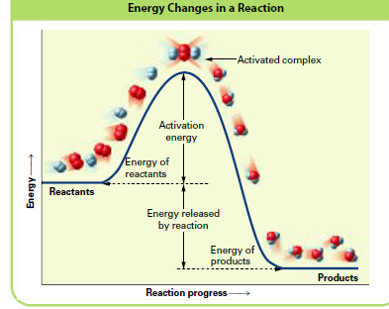
- Transition state
- Inhibitor
- FOUR factors that affect rate of reaction
  - Temperature
  - Concentration
  - Particle size (surface area)
  - Catalyst

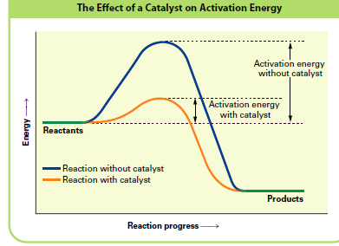
18.2 Reversible reactions & Equilibrium
- Reversible reactions
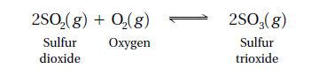
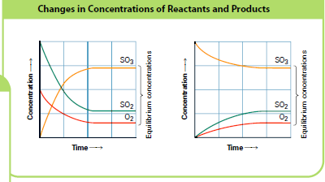
- Chemical equilibrium
- Equilibrium position
- Le Chatelier’s principle
  - Concentration
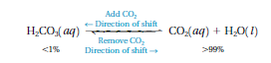
  - Temperature
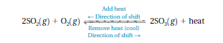
  - Pressure
- Equilibrium constant – K_{eq}
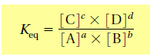
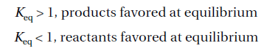
18.3 Solubility Equilibrium
- Solubility product constant K_{sp}
- The smaller the numerical value of the solubility product constant, the lower the solubility of the compound
- Common ion
- Common ion effect
