Thermochemical Equations and Calorimetry Name:____________________________

Short Answer

1. Draw an enthalpy diagram to represent the standard molar enthalpy of the combustion of octane. The standard molar enthalpy of combustion for octane is –5720.2 kJ/mol.

2. Methane burns in oxygen to form carbon dioxide and water. This process releases 882 kJ/mol of methane.

a) Write the thermochemical equation for this reaction.
b) If 15.0 g of methane is burned, how much heat is released?

3. Octane, C₈H_{18(l)}, is a component of the gasoline that is used as a fuel in automobiles. Octane reacts with oxygen to form carbon dioxide and water in a complete combustion reaction.
When 15.0 g of octane was completely burned in an experimental engine, 750 kJ of energy was released. What is the molar enthalpy of combustion for octane?

Problem: For the following questions, write the answers in the spaces provided. Use complete sentences in your answers. If the question requires mathematical calculations, show all of your work. Use diagrams, if appropriate. List procedure steps where appropriate.

4. 0.412 g of calcium reacts in a coffee-cup calorimeter that contains 200.0 g of water. The initial temperature of the water is 18.9°C, and the final temperature is 24.0°C. Calculate the standard molar enthalpy change for this reaction.

5. A mass of 100.0 g of dilute hydrochloric acid is placed in a coffee-cup calorimeter. The temperature of the solution is recorded to be 17.5°C. A piece of magnesium ribbon of mass 0.450 g is placed in the solution and the final temperature is recorded to be 39.6°C. Calculate the molar enthalpy change for this reaction:
Mg_{(s)} + 2HCl_{(aq)} → MgCl_{2(aq)} + H_{2(g)}

6. 50.0 mL of 0.500 mol/L of copper(II) sulfate solution is mixed with 50.0 mL of 1.00 mol/L solution of sodium hydroxide in a coffee-cup calorimeter. The temperature change is 5.32°C.
a) What is the enthalpy change for the reaction?
b) Write the thermochemical equation.

7. A chemist uses a coffee-cup calorimeter to neutralize completely 75.0 mL of 6.67 mol/L HCl with 75 mL of NaOH. The temperature change is 39.6°C.
a) Calculate the heat of neutralization, in kJ/mol, of HCl.
b) Write a thermochemical equation for the reaction.

For the following questions, use the graphics provided or draw your own, as directed. Add any missing labels, draw any missing parts, or use the graphics to help you answer a question.

8. Use the following enthalpy diagram to write the thermochemical equation for the reaction.

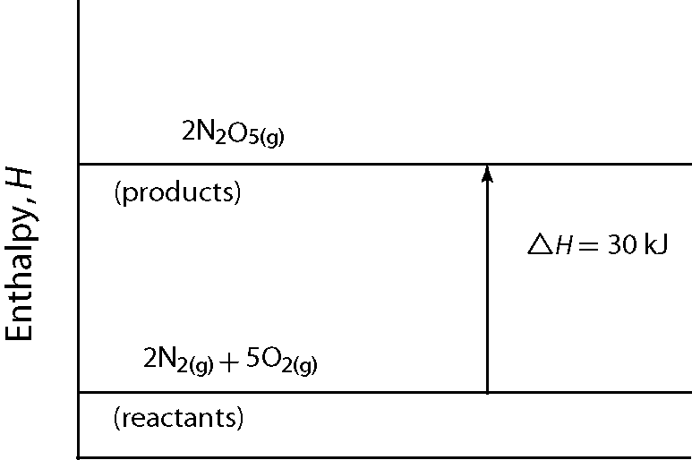
Thermochemical Equations and Calorimetry
Answer Section

SHORT ANSWER

1. ANS:
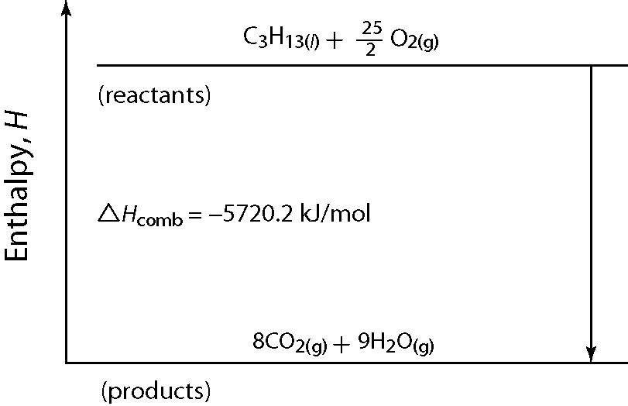

PTS: 1 DIF: intermediate REF: 16.2 STA: 324-1 | 324-5

2. ANS:
a) CH_{4(g)} + 2O_{2(g)} → CO_{2(g)} + 2H₂O_{(g)} + 882 kJ
b) 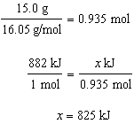
Burning 15.0 g of methane releases 825 kJ of heat.

PTS: 1 DIF: intermediate REF: 16.2 STA: 324-1 | 324-3

3. ANS:
a) M(C₈H₁₈) = 114.23 g/mol

amount C₈H₁₈ = 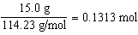
molar enthalpy of combustion = 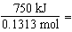 5712 kJ/mol
The molar enthalpy of combustion of C₈H_{18(l)} is 5.71 10³ kJ.

b) C₈H_{18(l)},₎ + O_{2(g)} → 8CO_{2(g)} + 9H₂O_{(g)} H_{comb} = -5.71 10³ kJ/mol C₈H_{18(l)}

PTS: 1 DIF: intermediate REF: 16.2 STA: 324-1 | 324-2 | 324-3

PROBLEM

4. ANS:

q_{lost by calcium} = | −q_{gained by water}
nΔH_{r} = | mcΔT
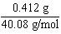 = | 0.0103 mol
0.0103 mol × ΔH_{r} = | 200.0 g × 4.184 J/g°C × 5.1°C
ΔH_{r} = | 4.14 × 10⁵ J/mol
The enthalpy change for the reaction of calcium in water is 4.14 × 10² kJ/mol Ca.

PTS: 1 DIF: intermediate REF: 17.1 | 16.2 STA: 324-2 | 324-3

5. ANS:

0.450 g ÷ 24.31 g/mol = | 0.0185 mol Mg
q_{reaction} = | −q_{gained by solution}
nΔH_{r} = | mcΔT
ΔT = 39.6°C − 17.5°C = | 22.1°C
ΔH_{r} = | (100 g × 4.184 J/g°C × 22.1°C) ÷ 0.0185 mol
= | 5.00 × 10⁵ J/mol
The enthalpy change for the reaction of magnesium with hydrochloric acid is 5.00 × 10² kJ/mol Mg.

PTS: 1 DIF: intermediate REF: 17.1 STA: 324-2 | 324-3

6. ANS:
a)
q_{reaction} = | −q_{gained by solution}
nΔH_{r} = | mcΔT
0.025 mol × ΔH_{r} = | 100.0 g × 4.184 J/g°C × 5.32°C
ΔH_{r} = | 8.9 × 10⁴ J/mol
The enthalpy change for this reaction is −89.0 kJ/mol CuSO₄.

b) CuSO_{4(aq)} + 2NaOH_{(aq)} → Cu(OH)_{2(s)} + Na₂SO_{4(aq)} H = –89 kJ

PTS: 1 DIF: intermediate REF: 17.1 | 16.2 STA: 324-2 | 324-3

7. ANS:
a)
0.0750 L × 6.67 mol/L HCl = | 0.500 mol HCl
q_{reaction} = | −q_{gained by solution}
nΔH_{r} = | mcΔT
ΔH_{r} = | (150.0 g × 4.184 J/g°C × 39.6°C) ÷ 0.500 mol
= | 49.7 kJ

b) HCl_{(aq)} + NaOH_{(aq)} → NaCl_{(aq)} + H₂O_{(l)} + 49.7 kJ

PTS: 1 DIF: intermediate REF: 17.1 | 16.2 STA: 324-2 | 324-3

8. ANS:
2N_{2(g)} + 5O_{2(g)} + 30 kJ → 2N₂O_{5(g)}

PTS: 1 DIF: intermediate REF: 16.2 STA: 324-5

