CHAPTER 8 PRACTICE TEST

Name: ______________________________ Date:_______________________________

Part A: True or False?

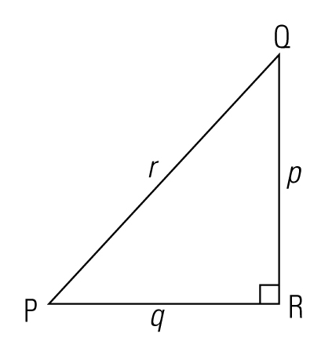

Given the diagram above, indicate whether the following are true or false. (10 marks)

1. Side QR is opposite ∠P. T F

2. Side PQ is the longest side. T F

3. r² = q² + p² T F

4. If ∠P = 53° then ∠Q = 43° T F

5. cos ∠Q = T F

6. cos ∠P = sin ∠Q T F

7. ∠P + ∠Q = 180° T F

8. tan ∠Q = T F

9. tan ∠P = T F

10. Side PR is adjacent ∠Q T F

Part B: Short Answer

Find the answers to the questions below.
11.
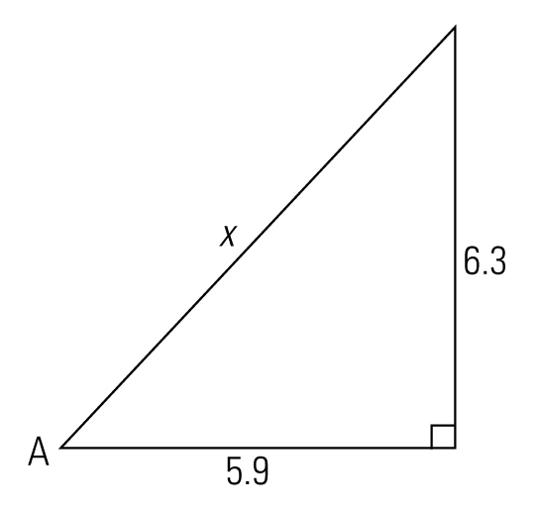
a) Find tan A

b) Find ∠A

12.
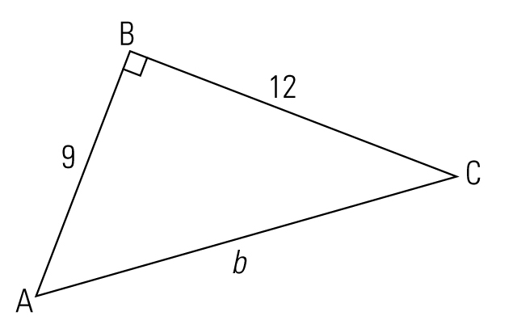
a) Find b

13.
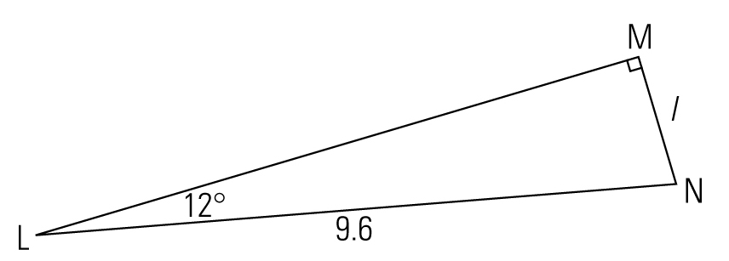
a) Find l

b) Find ∠N

14.
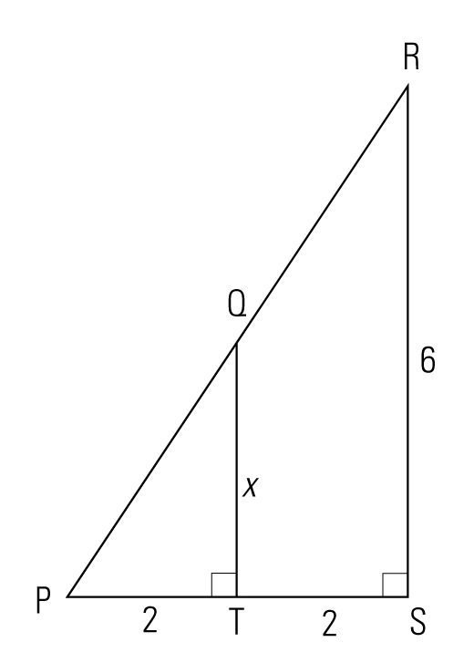
a) Find x

b) Find ∠P

c) Find PQ

Part C: Extended Answer

Show all work for part marks. Each question is worth 2 marks. At most, 1 mark will be awarded for the correct answer.

15. A rectangular plot is 10 m by 8 m. How far is it from one vertex to the opposite vertex to the nearest tenth of a metre?

16. A ladder 5 m long is placed against the side of a house so that it rests 4.2 m above the ground. How far is the base of the ladder from the base of the house?

17. Two identical pulleys are placed as shown in the diagram. If the distance between their centres is 45 inches, and the horizontal distance between their centres is 36 inches, what is the vertical distance between the centres?

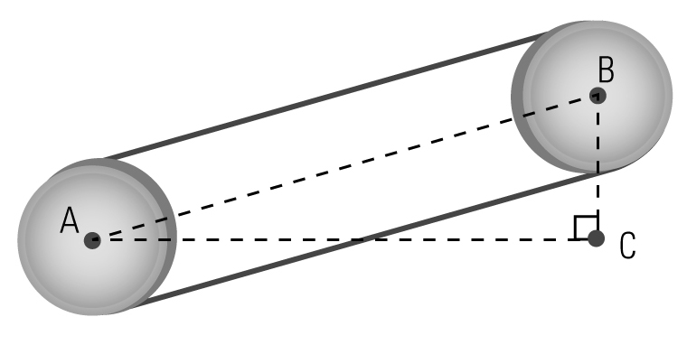

18. The angle of elevation of a roof top is 32°. If the vertical change in height is 4 feet 9 inches as indicated, how long must the rafter be?

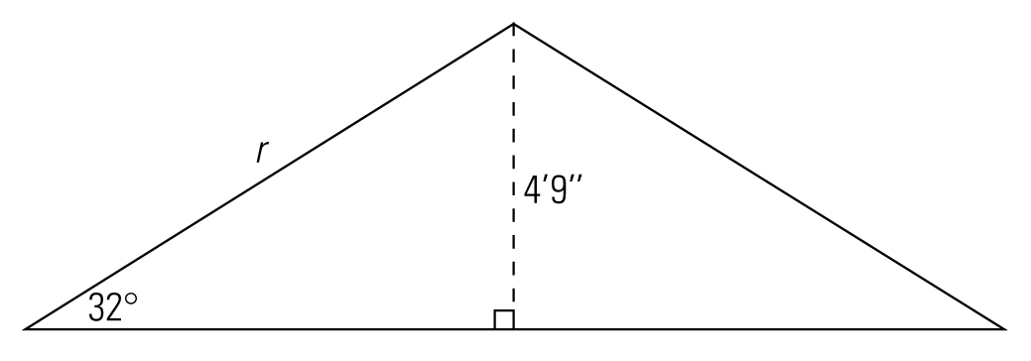

19. Marnie planted a tree and attached a guy wire to help support its straight growth. If the guy wire is 4.3 m long and is to be attached at an angle of elevation of 32°, how high up the tree will it reach?

20. A 6 m ladder is placed against a wall so that it forms a 70° angle with the ground. How far is the base of the ladder from the wall?

21. If a square-based pyramid has an angle of elevation of 50° and a slant height of 120 m, how wide is the pyramid?

22. A surveyor is trying to measure the distance AC across a river. From point C, directly across from point A, he walks along the bank to point B from which he sites A at an angle of 45°. If the distance BC is 120 yards, how far is it across the river?
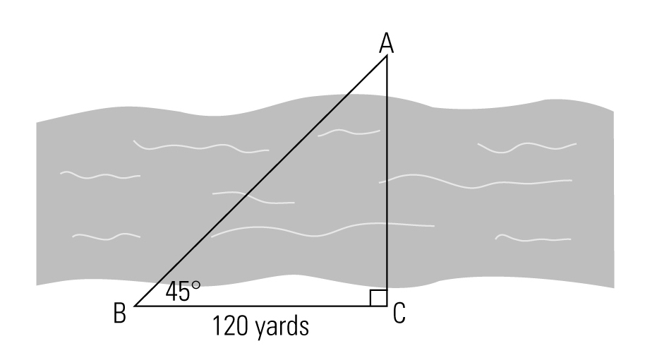

23. The rows in a theatre are arranged as indicated. If each tier is 100 cm wide and 45 cm above the one in front, what is the angle of elevation to the nearest degree?
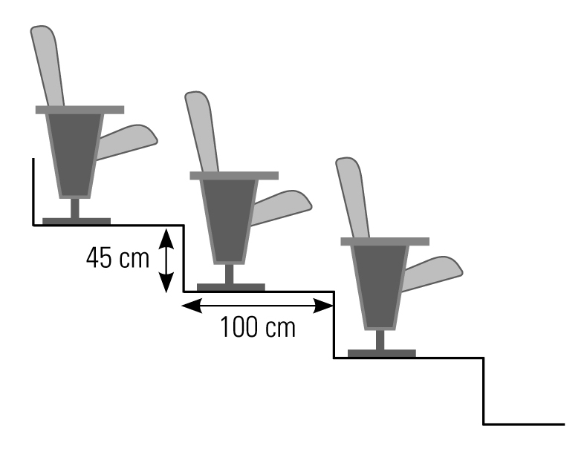

24. A tree broke and fell as indicated.
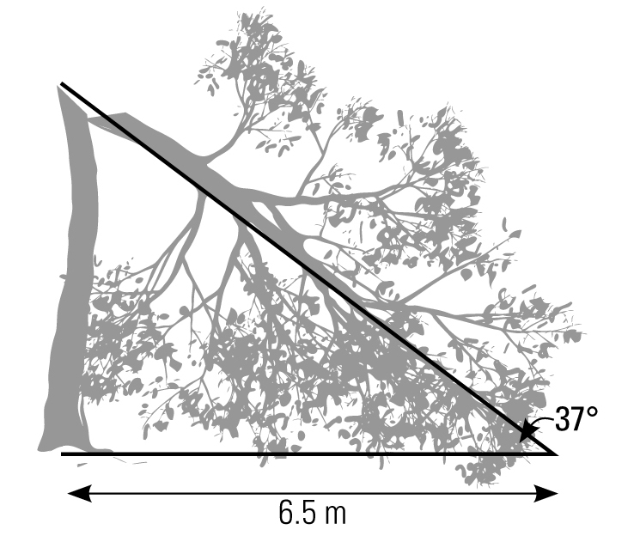
a) How far from the ground did it break?
b) How tall was the tree before it broke?

SAMPLE CHAPTER TEST SOLUTIONS

Part A: True or False?

1. (T)
Side QR is opposite ∠P.
Side p, or QR, is in the interior of ∠P.

2. (T)
Side PQ is the longest side.
PQ = r
Side r is the hypotenuse.

3. (T)
r² − p² = q²
From the Pythagorean theorem.
r² = q² + p²
Subtract p² from both sides.
r² − p² = q²

4. (F)
∠P = 53°
53° + ∠Q = 90°
∠Q = 90° − 53°
∠Q = 37°

5. (F)
cos ∠Q =
cos ∠Q =

6. (T)
cos ∠P =
= sin ∠Q

7. (F)
∠P + ∠Q + ∠R = 180°
∠P + ∠Q = 180° − ∠R
∠P + ∠Q = 90°

8. (T)
tan ∠Q =
tan ∠Q =

9. (T)

tan ∠P =
tan ∠P =

10. (F)

PR is opposite ∠Q, or adjacent ∠P.

Part B: Short Answer

11. a)
tan A =
tan A 1.1
b)
∠A = tan⁻¹
∠A 47°

12. 9² + 12² = b²
81 + 144 = b²
225 = b²
b =
b = 15
Alternative Solution
Since 9 equals 3 multiplied by 3 and 12 equals 3 multiplied by 4, the hypotenuse is 3 multiplied by 5 equals 15, multiples of the 3-4-5 right triangle.

13. a) sin 12° =
l = 9.6 sin 12°
l = 2
b) ∠L + ∠M + ∠N = 180°
12° + 90° + ∠N = 180°
102° + ∠N = 180°
∠N = 180° – 102°
∠N = 78°

14. a) PS = 2 + 2
PS = 4
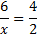
4x = 12
x =
x = 3
b) ∠P = tan⁻¹
∠A = 56°
c) 2² + 3² = PQ²
4 + 9 = PQ²
13 = PQ²
PQ =
PQ 3.6

Part C: Extended Answer

15. AB² + AD² = BD²
10² + 8² = BD²
100 + 64 = BD²
BD² = 164
PQ =
PQ 12.8
It is approximately 12.8 m from one vertex to the opposite.

16.
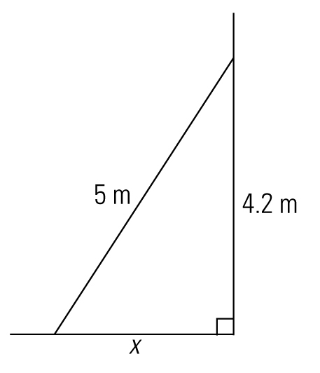
4.2² + x² = 5²
x² = 5² – 4.2²
x = 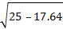
x =
x 2.7
The base of the ladder is approximately 2.7 m from the house.

17. a² + b² = c²
a² + 36² = 45²
a² + 1296 = 2025
a² = 2025 – 1296
a² = 729
a =
a = 27
The vertical distances between the centres is approximately 27 in.
Alternative Solution
Students may realize that 45 equals 9 times 5 and 36 equals 9 times 4, so this represents a 3-4-5 right triangle and the other leg would be 9 times 3 equals 27 in.

18. Change 4′9″ to feet by first changing 9″ to a fraction of a foot.

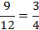
= 0.75 ft
sin 32° =
r sin 32° = 4.75
r =
r 9.0
The rafter is approximately 9 ft long.

19.
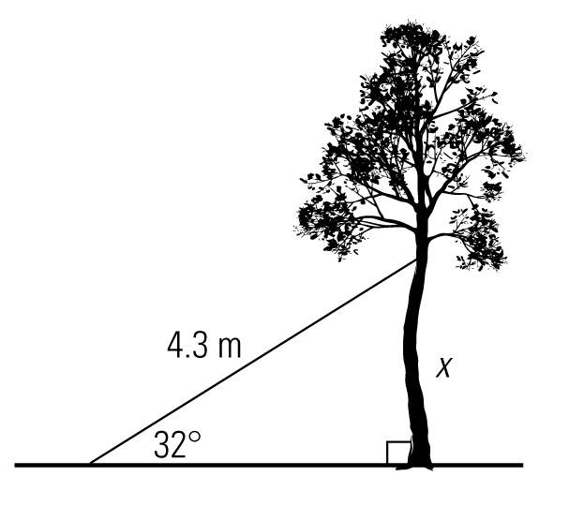
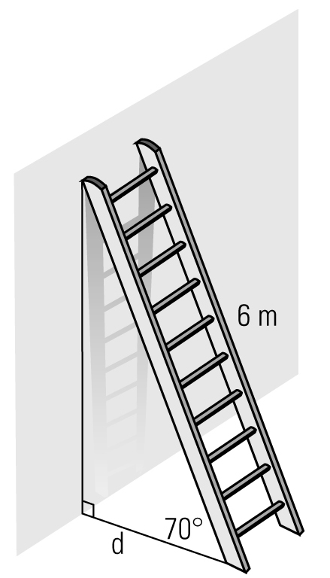
sin 32° =
x = 4.3 sin 32°
x = 2.3
It would be about 2.3 m up the tree.

20. cos 70° =
6 cos 70° = d
r 2.1
It is approximately 2.1 m from the wall.

21.
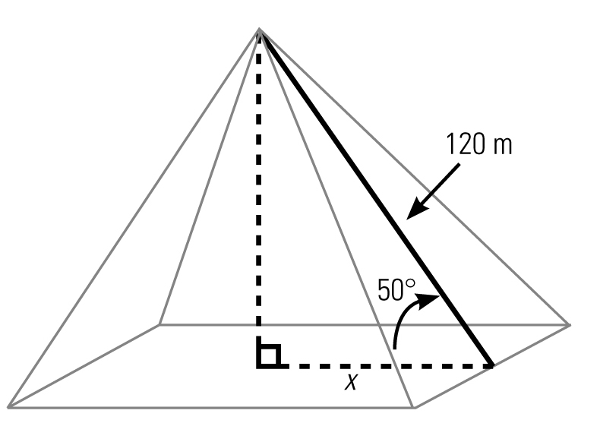
cos 50° =
120 cos 50° = x
x 77.1 m
The width of the pyramid is therefore approximately 2 77.1 m or 154.2 m.

22. Since this is a 45-45-90 triangle, AC equals BC, which equals 120 yards.

Alternative Solution
tan 45° =
tan 45° =
AC = 120 tan 45°
AC = 120
Therefore, it is 120 yards across the river.

23.
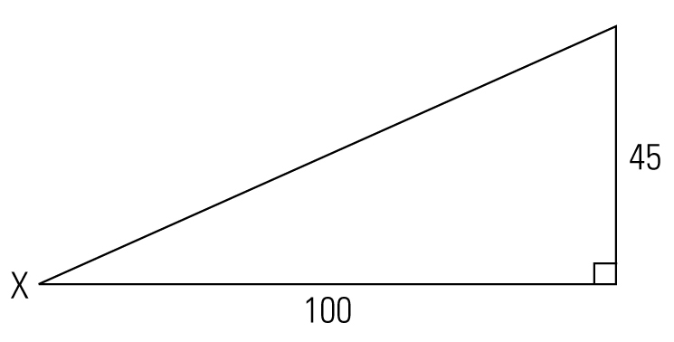
tan X =
X = tan⁻¹
X 24°
Therefore, the angle of elevation is approximately 24°.
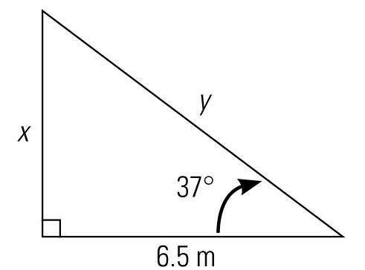
24. a) Let the height of the stump be x.
tan 37° =
x = 6.5 tan 37°
x 4.9 m
The tree broke 4.9 m from the ground.
b) Let the length of the piece that broke off be y.
cos 37° =

y cos 37° = 6.5
y =
y 8.1 m
4.9 + 8.1 = 13
The tree was 13 m tall.
Note: Students should not use the Pythagorean theorem to determine the length of the broken piece, as they will be compounding rounding errors.

