EXCEL 8

Use the following website to get your info to type and to watch the videos. *There is no sound but there are written instructions that pop up.
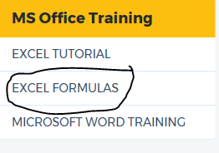
http://www.free-training-tutorial.com/
Go down to MS Office Training and select: “Excel Formulas”

Look in the “Formulas and Function: list.

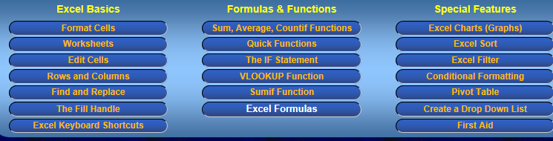

Excel Bonus 1:
- Go into the “Sum, Average, Countif Functions” button. Select “Max, Min – Highest and Lowest Numbers”.
- Type the data given in the video (or click on the “Try it Yourself” button), and use a formula to find the highest and lowest grade as shown.
- Add additional rows to find “The highest grade in Math”, “The lowest grade in Math, The highest grade in History”, “The lowest grade in History”, The highest grade in English”, “The lowest grade in English”.
- Format it to look nice like the video or like the previous assignments we have done in class.
- Save as “Excel Bonus 1”.
- Don’t print until you are done all these bonus assignments.

