From Everest to the snows of Kilimanjaro
Luke Timmerman's next mountain-climbing adventure to raise money for Fred Hutch cancer research
December 12, 2018 • By Sabin Russell
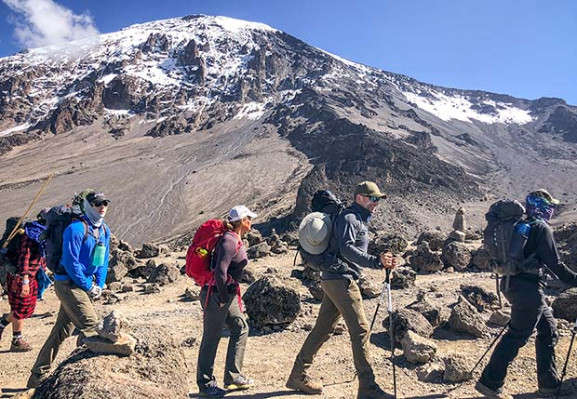Luke Timmerman and his team of Hutch supporters will climb Mount Kilimanjaro in July. They will follow the footsteps of this year's Climb to Fight Cancer expedition (above) that reached the 19,000-foot summit in September. Photo courtesy of Lisa Carlson

What’s a mountaineer to do after summiting Mount Everest?
It did not take long for Luke Timmerman to come up with a fresh idea. The Seattle biotechnology writer is now organizing a climb this July to the summit of Mount Kilimanjaro, which at 19,000 feet is the tallest peak in Africa.
It was Timmerman’s idea to piggyback a fundraiser for Fred Hutchinson Cancer Research Center to his climb of Mount Everest last May. When he unfurled a Hutch banner at the top of the world on May 22, he had raised $340,000 through Climb to Fight Cancer.
Now his goal is to top $1 million.
For Timmerman, Kilimanjaro is not just another peak to summit; it is a fresh opportunity to raise money for science in Seattle. He unveiled his summer plan today to the subscribers of his online newsletter for biotech executives, the Timmerman Report. He plans to tap his network to recruit climbers for his team and he will be helping with the fundraising in the months to come.
“This is going to be bigger than Everest,” he said. “It’s not a bigger mountain, but it’s a bigger fundraising idea.”
His summit of Everest excited and inspired his network of subscribers, many of them successful biotechnology entrepreneurs. For the Kilimanjaro climb, he has already signed up 16 participants who have pledged to raise $50,000 each to join him. That is potentially $800,000 for Climb to Fight Cancer, and he has just launched the plan.
As with his Everest climb, Timmerman plans to hold two Cancer Summits this spring, one in Boston and the other in Seattle at Fred Hutch. At these fundraising conferences, he pulls together experts in the biotech and pharmaceutical industries to talk about new science, new companies and trending topics.

A seven-day climb in Tanzania
Kilimanjaro, a snowcapped African volcano, rises dramatically from the Serengeti plains. It has a special allure for Americans because Ernest Hemingway made the name famous with "The Snows of Kilimanjaro," a short story often considered among his finest works.
This expedition will begin with participants gathering at Kilimanjaro International Airport, in Tanzania, on July 18. The summit attempt will come on the sixth day of a seven-day climb, which is designed to acclimate expedition members to the extremely thin air at the summit. Although it is considered a “walk-up” mountain, estimates are that half of those attempting the climb each year — many of them unprepared tourists — are turned back by exhaustion or altitude sickness.
To boost the likelihood of success, Timmerman has turned to the same guide service that took him to Everest: Seattle-based Alpine Ascents International. Bellingham-based Eric Murphy, who accompanied Timmerman to the Everest summit last May, will lead the Africa expedition.
“What I’m saying is, ‘Come join me and the best guide I know on Kilimanjaro,’” Timmerman said. “Eric is Alpine Ascents’ Kilimanjaro manager. He is the most experienced western guide on that mountain, and he has made more than 100 summits.”
Two Fred Hutch employees have signed up for the climb. One is Kelly O’Brien, vice president of Philanthropy, the Hutch’s fundraising arm. An experienced mountaineer herself, she championed Timmerman’s idea of climbing Mount Everest after he approached the Hutch a year ago.
“She was the person who made the key decision to greenlight the Everest climb. She believed in me early on, and I am grateful for that,” Timmerman said.
O’Brien noted that the quest to reach summits is deeply meaningful to cancer patients and researchers alike. “Mountaineers have been supporting Fred Hutch through Climb to Fight Cancer for more than 20 years,” she said. “Their journeys can be a powerful inspiration to patients as well as their family and friends. We are thrilled to partner with Luke and the amazing community of biotech leaders he has recruited to raise funds and awareness for Fred Hutch and our goal of curing cancer.”
Also joining the Kilimanjaro climb is Dr. Kristin Anderson, a postdoctoral fellow in the immunotherapy lab of Dr. Phil Greenberg. She studies how to engineer immune cells to be more effective in killing ovarian cancer cells, which — like those of other solid tumors — are adept at shutting down the body’s attempts to eliminate them.
Exempt from the hefty fundraising goal, her role on the trip will be to provide scientific background to expedition members. She has another motive to join. Seven years ago, Anderson was diagnosed with breast cancer at the age of 28. “I know very clearly that research is what saved my life. It’s very important for me to pay it forward, so that others have that same outcome,” she said.
Despite the audacious fundraising goal Timmerman has set for his team, he is confident that each of them will reach it and will make it to the top of the mountain. Each will have their own personal fundraising pages, and those who are interested in supporting them may follow the climb here.
“This is a tremendous group,” Timmerman said. “I’m feeling great physically and emotionally. It’s really a special position I’ve gotten into. I said I was going to climb Everest and raise money for science at Fred Hutch. Now, I’ve got an opportunity to really run with it.”

