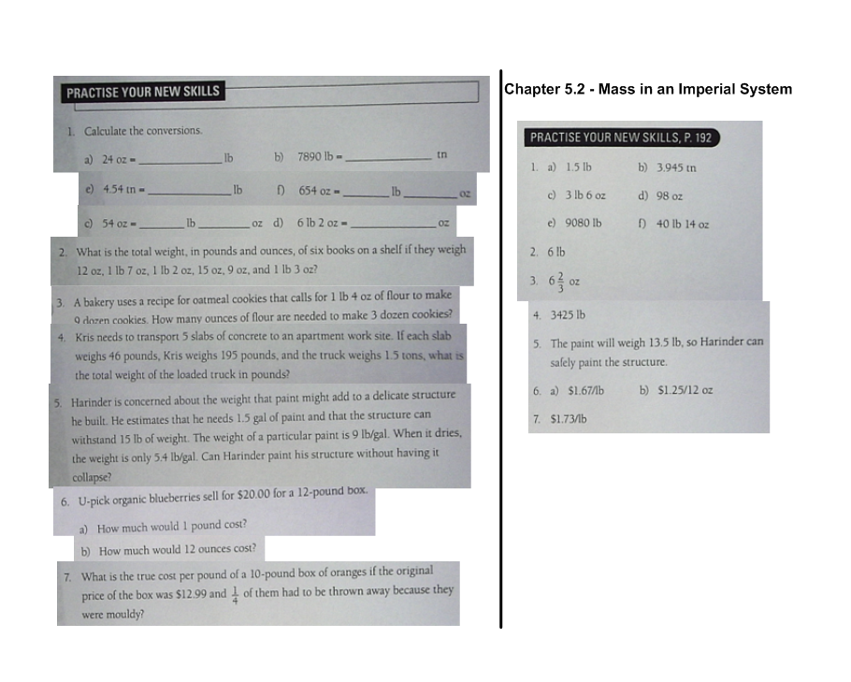
Geometry, Measurement & Finance 10

