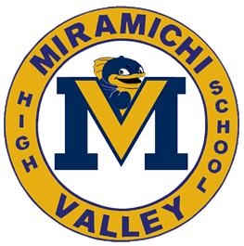
Course Outline Science 9
2020-2021
Stephanie Shannon

The aim of science education in the Atlantic provinces is to develop scientific literacy. Scientific literacy is an evolving combination of the science-related attitudes, skills, and knowledge students need to develop inquiry, problem-solving, and decision-making abilities.

Units

1. Space Exploration

Strand 1- The Beginning of the Solar System
Strand 2 - Composition and Characteristics of the Solar System
Strand 3 - Composition and Characteristics of the Universe

2. Reproduction

Strand 1 – Cellular Processes
Strand 2 – Asexual and Sexual Reproduction
Strand 3 – Genetic Changes

- Scientific Literacy or STEM project(s)

Formative assessments will be given to provide feedback, determine what you can do well and what you need to improve upon, help you develop the ability to self-assess and involve you actively in your learning.
Summative assessments will be used to evaluate your learning at the end of an instructional period. Work that includes applied knowledge and understanding, communication, investigation, making connections, and research skills (to be assessed through projects, answers, laboratory work and reports, etc.) will also be part of the summative mark.

Evaluation (subject to change)

Summative Assessments 80%
Final Assessment 20%

Materials
Pen/Pencil Notebook/Binder Scientific Calculator Electronic Device

Extra Help
Extra help is available as needed

Expectations of you as a student in Science 9
- The pass mark for science is 60%.
- Hand in assignments on time. A percentage of the original value of the assignment will be lost each day late.
- If you are not here a day for any reason, it is your responsibility to get notes and the assignments you missed.
- If you are absent for a test or quiz, you must write the test 1 day within your return to school.
- Be on time and make full use of class-time.

