CUPE LOCAL 3863
JOHN JAMES BRYENTON
MEMORIAL BURSARY

The City of Miramichi Inside Workers CUPE Local 3863 has (1) bursary valued at $500.00 in memory of John James Bryenton. The bursary is for the students' first year attendance at any university, college, or community college. Preference will be given to sons and daughters or legal wards of members of CUPE Local 3863.

Basis of award is marks, aptitude, promise and financial need.

Application forms are available from members of the Education Committee of Local 3863 or your high school guidance counsellor. The application must be returned to the Education Committee of Local 3863 no later than April 30, 2021.

Successful applicants will be notified as soon as possible. The cheque will be awarded upon verification of attendance at the university, college or community college.

All inquiries regarding the bursary should be directed to:

CUPE LOCAL 3863
Education Committee
P.O. Box 652
Miramichi, NB
E1V 3T7
Bev Jones, Education Committee (506) 773-7959
Stacey Hare, Education Committee (506) 624-4868

GOOD LUCK!!!

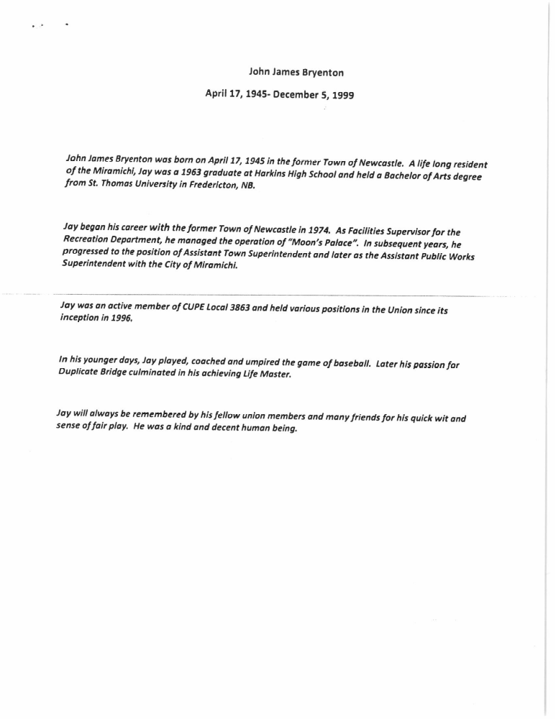
CUPE LOCAL 3863
JOHN JAMES BRYENTON MEMORIAL BURSARY

APPLICATION FORM
Personal Data:

Name: __________________________________________

Address: ________________________________________

________________________________________

Postal Code: ____________________ Telephone: ____________________

Date of Birth: ______________________

High School: _______________________

Father's Name: ________________________ Occupation: ___________________

Mother's Name:________________________ Occupation: ___________________
------------------------------------------------------------------------------------------------------------
Family Income: (Please check one)

___________ between $20,000 - $30,000

___________ between $30,000 - $40,000

___________ between $40,000 - $50,000

___________ between $50,000 - $60,000

___________ Over $60,000
------------------------------------------------------------------------------------------------------------
Have you received any other scholarships/bursaries?
____ Yes _____ No

If yes, please list
________________________________________________________________________
________________________________________________________________________
________________________________________________________________________
________________________________________________________________________
________________________________________________________________________________________________________________________________________________

Attach separate sheet if necessary.
Ages of other dependant children in family and level of schooling
________________________________________________________________________________________________________________________________________________________________________________________________________________________

NOTE:
Please attach with your application a transcription of marks and two letters of reference from the following:

- academic
- personal from non-relative
------------------------------------------------------------------------------------------------------------

Name of university, college, or community college you plan to attend
________________________________________________________________________________________________________________________________________________

Course of Study _________________________________________________________

Extra Curricular Activities

Indicate your outstanding achievements and abilities or talents in particular fields such as music, athletics, dramatics, science, creative writing, speech contests, etc.
________________________________________________________________________________________________________________________________________________________________________________________________________________________________________________________________________________________________
________________________________________________________________________

List activities in which you have participated both in and out of school: Examples: Student Council, Scouts/Girl Guides, Church Groups, etc.
________________________________________________________________________________________________________________________________________________________________________________________________________________________________________________________________________________________________

Briefly explain why you should be considered for this bursary
________________________________________________________________________________________________________________________________________________________________________________________________________________________________________________________________________________________________________________________________________________________________________

Signature of Applicant: _________________________________ Date: _____________

