SEMESTER ONE: Fall 2023
Number Relations & Functions 10

Teacher Mrs. Mutch Barbara.Mutch@nbed.nb.ca

Homework/Daily lessons: Microsoft Teams
Topics
Chapter 4: Roots and Powers (12 days)
- Irrational Numbers, Real Number System, Radicals

- Laws of Exponents

Chapter 3: Factors and Products (13 days)
- Prime factors, Greatest Common Factors, Least Common Multiples

- Monomials, Binomials, Trinomials, Substitution, Multiplication of Polynomials, Common factors of Polynomials, Trinomial Factoring, Difference of Squares

Chapter 6: Linear Functions (26 days)
- Slope, parallel/perpendicular lines, x and y intercepts, domain and range

- Equations of a line
  - Slope Intercept form
  - General form
  - Slope-Point form

- Graphs and equations

Chapter 5: Relations and Functions (13 days)
- Analyzing Data, Graphs & Situations,

- Domain/range, discrete/continuous, functions/non-functions comparison

- Linear relations
  - Dependent/Independent Variables
  - Equations, ordered pairs, linear situations
  - Relations and Functions ( f(x) )

Supplement: Distance / Midpoint (4 days)
- Distance between points

Chapter 7: Systems of Linear Equations (11 days)
- Modeling situations, point of intersection
- Problem solving

EVALUATION:
**Academic Incentive Program:**
Tests / Quizzes / Assignments 70% 85% OR 50%
Exam 30% 15% OR 50%

*A mark of 60% is required to receive a passing grade.*

To qualify for the **Academic Incentive Program**, a student must meet the following criteria:
1) have missed no more than 7 days in any course as of the Friday prior to an exam period
2) have completed all requirements for the course to the satisfaction of the teacher
3) have a passing grade in the course going into the exam

NOTE: Exceptions to the attendance requirement will only be extended to days missed for school sponsored activities or as a result of a death in a student’s family.
Expectations:

Expectation is to follow the school rules, come to class prepare to do work.
You are expected to bring your notebooks, pencils and calculators every day. You are required to check in everyday you are doing home learning.

Attendance:

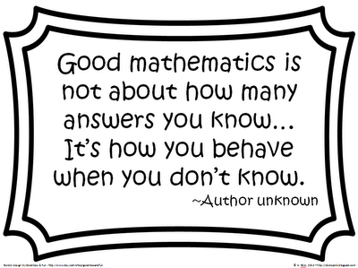
If you miss any work it is your responsibility to get caught up.

