
Pre-Calculus 110
Course OUTLINE – Fall 2024

Teacher: B. Mutch

Texts: Pre-Calculus 11; McGraw-Hill Ryerson

ONLINE LEARNING: Microsoft Teams & One Note – Class Notebook



Course Description:
This elective course follows Foundations of Mathematics 11, and is the first course in the Pre-Calculus pathway that can be selected by students. This pathway is designed to provide students with the mathematical understandings and critical-thinking skills identified for entry into post-secondary programs that require the study of theoretical calculus.

Materials Needed:
- Pencils and an eraser
- Notebook/Binder to maintain daily notes and homework exercises
- Scientific Calculator
- A box of Kleenex would be appreciated

Expectations:
The pace of this course will be rapid. Students will be expected to maintain excellent attendance. In the event of an absence, students are responsible for all missed work. (Please check the Math website noted above for missed notes and assignments.) If a student is absent for a test without a valid excuse, they will be given a mark of zero. It will be the responsibility of the student to present a satisfactory written excuse and arrange to write the test on his or her own time.
Topics:
Quadratics Quadratic Inequalities
Rational Expressions Trigonometry (Euclidean and Cartesian)
Radicals Systems of Quadratic Equations
Absolute Value

Evaluation: * Academic Incentive Options…
Tests / Quizzes / Assignments 70 % 85 % OR 50%
Exam 30 % 15 % 50%
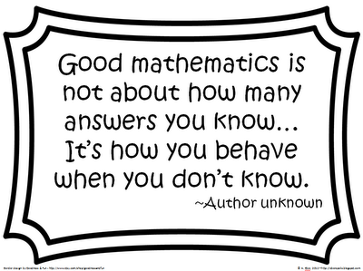
* To reach an academic incentive, a student must meet the following criteria...
1) have missed no more than 7 days in any course. (3 Tardy = 1 absence)
2) have completed all requirements for the course to the satisfaction of the teacher.
3) have a passing grade in the course going into the exam.

NOTE: Exceptions to the attendance requirement will only be extended to days missed for school
sponsored activities or as a result of a death in a student’s family.

To Learn Math Is To Do Math !!!

