
Pre-Calculus 12A
Course OUTLINE – Fall 2024

Teacher: B. Mutch,

Texts: Pre-Calculus 12; McGraw-Hill Ryerson

ONLINE LEARNING: : Microsoft Teams & One Note – Class Notebook



Course Description:

This elective course follows Pre-Calculus 110, and is the second course in the Pre-Calculus pathway that can be selected by students. This pathway is designed to provide students with the mathematical understandings and critical-thinking skills identified for entry into post-secondary programs that require the study of theoretical calculus.

Materials Needed:

- Pencils and an eraser
- Notebook/Binder to maintain daily notes and homework exercises
- Scientific Calculator
- Electronic Device to access Online Learning Platforms

Expectations:

The pace of this course will be rapid. Students will be expected to follow in-class and online learning. In the event of an absence, students are responsible for all missed work. All notes and videos will be available in One Note. If a student is absent for a test without a valid excuse, they will be given a mark of zero. It will be the responsibility of the student to present a satisfactory written excuse and arrange to write the test on his or her own time.
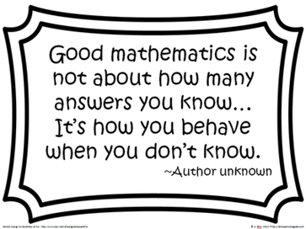
Topics:

Functions
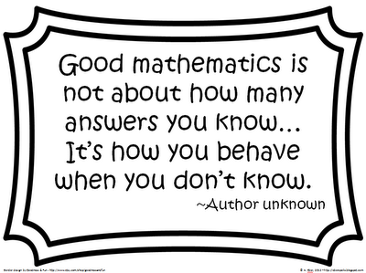
Trigonometry – Radian Measure and the Unit Circle
Graphing Trigonometric Functions
Exponential and Logarithimic Functions
Proving Trigonometric Identities

Evaluation:
EVALUATION:
**Academic Incentive Program:**
Tests / Quizzes / Assignments 70% 85% OR 50%
Exam 30% 15% OR 50%

*A mark of 60% is required to receive a passing grade.*

To qualify for the **Academic Incentive Program**, a student must meet the following criteria:
1) have missed no more than 7 days in any course as of the Friday prior to an exam period
2) have completed all requirements for the course to the satisfaction of the teacher
3) have a passing grade in the course going into the exam

NOTE: Exceptions to the attendance requirement will only be extended to days missed for school sponsored activities or as a result of a death in a student’s family.

Attendance:

If you miss any work it is your responsibility to get caught up.

To Learn Math Is To Do Math !!!

