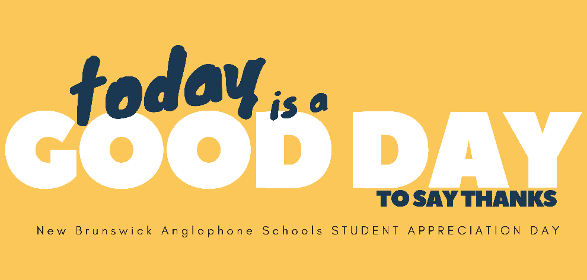

Dear ASD-N Families,
As you know, this year has been an exceptional challenge for everyone across our province, country and world.
We are also aware that we have asked our students to be incredibly adaptable and resilient as restrictions on mask wearing, in-school learning and blended learning change from day to day. We want to take this opportunity to share our gratitude with our students.
On June 9th and 10th, the four Anglophone School Districts will be holding Student Appreciation Day! June 9th will be for Grades Kindergarten to Grade 12 and June 10th will be to celebrate those students engaged in blended learning on June 9th. Some schools have opted to extend this later into the week.
Schools across our district are taking part in different ways, and celebrations will be as unique as each school is. The whole point is to let our students know how much we appreciate them – that might be done through one special activity, some announcements or an entire day of celebrations!
We know that COVID-19 has impacted our ability to show school spirit in the traditional ways. We hope this will be a fun and celebratory way to show our students our gratitude. Thank you!

Sincerely,
Everyone at ASD-N

